**Functional Library**

**Test Suite**

     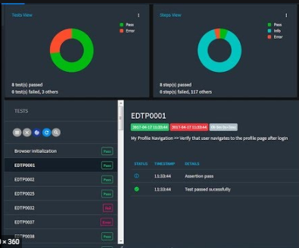

STEP CLASSES

POI

Apache

**Extent Report**

**Selenium WebDriver**

PAGE CLASSES

STARTUP SCRIPT

(BASE TEST)

Config file (.properties)

TERMINATION SCRIPTS

BASE PAGE

DATA PROVIDER

TEST SCRIPT